Unit Testing:

The following screenshots demonstrate the register nurse user story. As a nursing student, I want to register so that I can use the app. A unit test that acts like a nurse submitting correct registration information, like their name, student ID, college, course, email, and password. This test checks that the system can handle successful registration inputs appropriately and that the main features perform as they should.

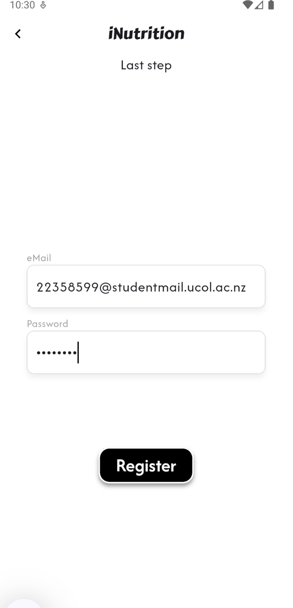


The screenshot below displays a patient profile being created successfully in the system.
The second screenshot shows how the nurse manages that patient on the nurse dashboard.

These screenshots demonstrate the capacity to create and store patient data related to a nursing account.
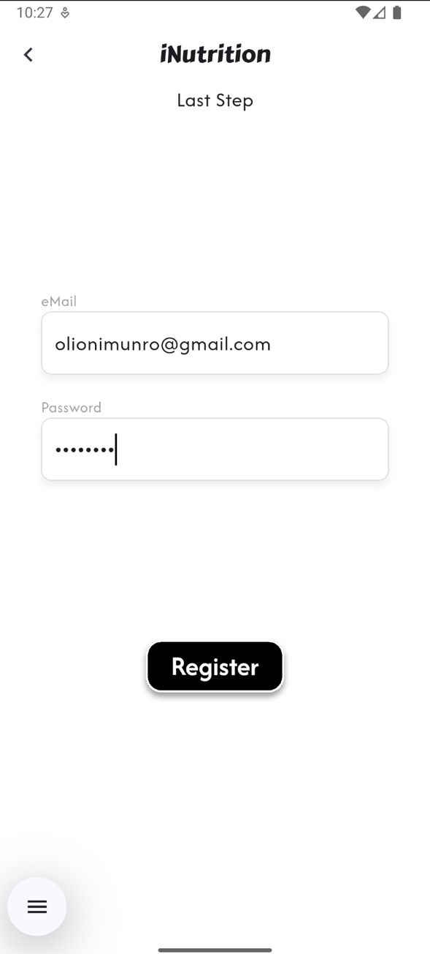
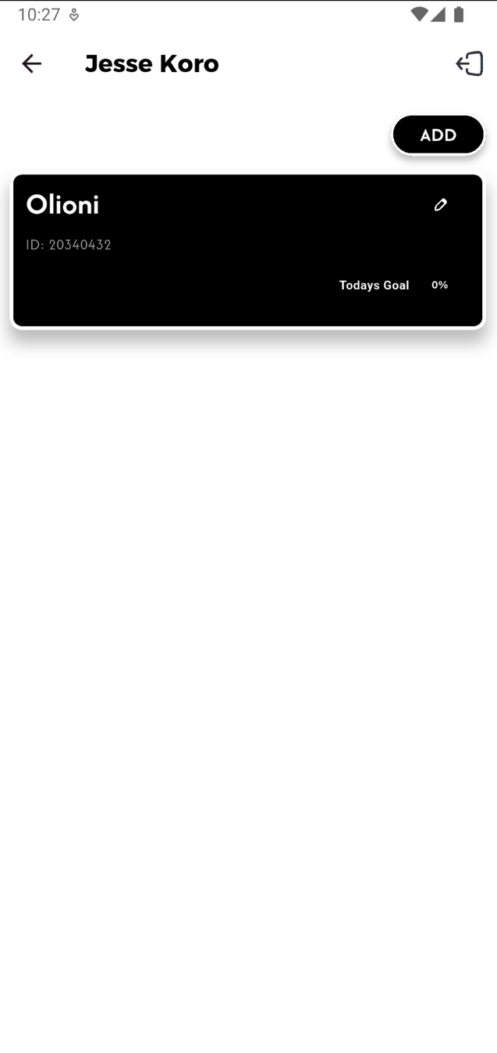
How patient information is retrieved and displayed on the nurse dashboard for management and monitoring. This supports the user story: “As a nurse, I want to register and manage patients so I can monitor their progress.” It also exhibits functioning logic that connects the patient creation procedure to the nurse dashboard view, confirming data flow between Firestore and the UI.

These screenshots are valuable because they show that both unit-level and functional logic have been properly built and tested. They back up what the inspection found — like the need to handle duplicates, validate user input, and ensure key elements like the dashboard are visible. Together, they highlight how inspection and testing work side by side to make the system more reliable and user-friendly.

